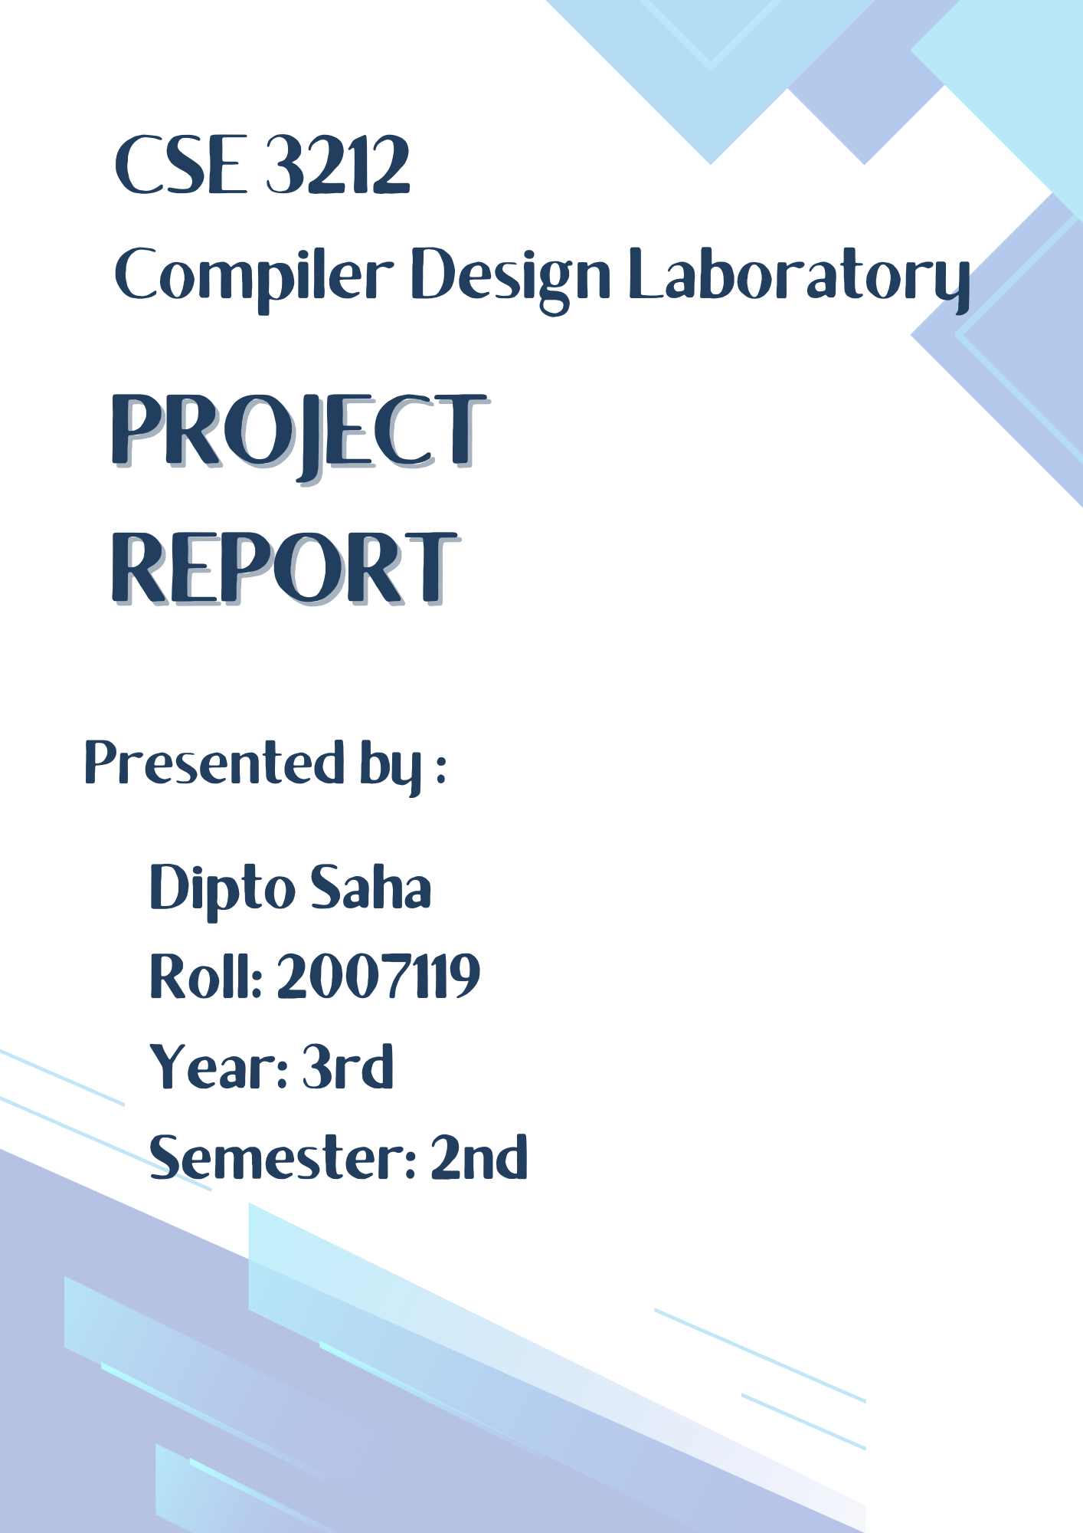


Objectives:

- To perform lexical analysis using Flex for tokenizing input.

- To conduct syntax analysis using Bison for parsing tokens.

- To implement semantic analysis to ensure program correctness.

- To execute code by interpreting expressions and control structures.

- To handle errors with descriptive messages for users.

- To support mathematical and trigonometric functions.

- To recognize and exclude comments from program logic.

- To facilitate input/output through files.

- To define custom grammar rules for specific keywords.

Project Overview :

Compilers are integral to modern computing, serving as the bridge between human-readable programming languages and the binary instructions that computers execute. They enable developers to write complex, abstract code in high-level languages like C, Python, or Java, which is then systematically transformed into low-level machine code. This transformation ensures that the written instructions are compatible with the underlying hardware architecture, making them executable on a computer system.
The compilation process can be divided into several key stages: lexical analysis, syntax analysis, semantic analysis, optimization, and code generation. Each stage has its own role, working in harmony to convert source code into efficient, error-free machine code. Lexical analysis identifies and classifies components of the source code, such as keywords, identifiers, literals, and symbols. Syntax analysis ensures the program adheres to the grammatical rules of the language, while semantic analysis checks for logical consistency. Optimization fine-tunes the code to improve performance, and finally, code generation produces the machine-level instructions.
In this project, we leverage Flex (Fast Lexical Analyzer) and Bison (GNU Parser Generator) to implement a fundamental compiler. Flex plays a crucial role in the lexical analysis phase. By defining patterns and regular expressions, it generates a scanner that reads the input program and breaks it into tokens—basic units like keywords (int, if, while), numbers, operators, and punctuation. The scanner ensures that each part of the program is correctly identified and categorized.
Bison complements Flex by handling the syntax analysis phase. Using a defined set of grammar rules, Bison validates the program's structure and ensures that tokens identified by Flex form meaningful constructs. For example, it checks whether expressions, conditional statements, and loops are syntactically valid. If errors are found, Bison generates helpful messages to guide users in correcting their code.
Together, Flex and Bison enable us to build a simple but functional compiler capable of supporting basic programming features. These include:
- Mathematical expressions: Handling arithmetic operations like addition, subtraction, multiplication, and division.
- Control structures: Supporting loops (for, while) and conditional statements (if-else, switch-case).
- File input/output: Allowing programs to read from and write to files.
- Error handling: Identifying and reporting syntax or semantic errors with clear feedback for the user.

Lexical Analysis
Lexical analysis is the first phase of a compiler, where the source code is converted into a sequence of meaningful symbols called tokens. This process breaks down the input into smaller units such as keywords, operators, identifiers, literals, and punctuation marks.
In our project, Flex is utilized to perform lexical analysis. It defines patterns using regular expressions to identify various components of the input code.

Key Features of the Lexer File

1. C Declarations Section:
  - Includes necessary headers (stdio.h, string.h, math.h, stdlib.h) and the header file for the parser (2007119.tab.h).
  - Declares macros and reusable patterns (e.g., variable for identifiers).
2. Token Patterns:
  - Matches various tokens, including:
    - Data types: int, float, char.
    - Control flow: SWITCH, CASE, DEFAULT, Hoieta (if), Othobaeta (else), and While.
    - Mathematical operations: add, sub, mul, div, and power.
    - Relational operators: <, >, <=, >=, ==, and !=.
    - Logical operators: &&, ||.
    - Increment/Decrement: ++, --.
    - Parentheses, braces, commas, semicolons, and colons.
    - Functions: palindrome, prime, factorial, power, and trigonometric operations like SIN, COS, and TAN.
3. Special Tokens:
  - Custom keywords and constructs:
    - "loop", "printkor", "Even_Odd", "year", and others for specific features.
  - Mathematical functions and control constructs specific to the project (e.g., Even_Odd and Hoieta).
4. Numeric Literals:
  - Recognizes integers ([-+]?[0-9]+) and floating-point numbers ([-+]?[0-9]*"."[0-9]+).
  - Converts them to their respective types (yylval.iv and yylval.fv).
5. Comments:
  - Handles single-line comments ("//".*) and multi-line comments ("/*"([^*]|\*[^/])*"*/").
6. Error Handling:
  - Reports unrecognized characters and skips over whitespace, tabs, and newlines.
  - Reports divide by zero .

How the Lexer Works

1. Input Handling:
  - Reads the input from input.txt and writes the output to output.txt.
2. Pattern Matching:
  - Flex scans the input code and matches it against defined patterns.
  - When a match is found, it returns the corresponding token to the parser (yylval is used to pass token values).
3. Error Reporting:
  - Any unmatched character triggers the yyerror() function, which prints an error message.
4. Integration with Parser:
  - Tokens defined in the lexer correspond to grammar rules in the Bison file (2007119.tab.h).

Key Components of the Grammar

- Header Section (%{ ... %}):
  - Includes necessary libraries like <stdio.h> and <stdlib.h>.
  - Declares a global store array for storing variables and their values.
  - Introduces indexx as a global index for the store array.
- Union Definition (%union):
  - Declares the possible types of semantic values for tokens: int, float, and char*.
- Token Declarations (%token):
  - Defines the set of terminal symbols (tokens) recognized by the lexer.
  - Includes tokens for keywords (INT, FLOAT, MAIN_FUNC, etc.), operators (PLUS, MINUS, etc.), and special tokens like VARIABLE and NINT.
- Precedence and Associativity Rules (%left, %right, %nonassoc):
  - Establish precedence and associativity for operators to resolve ambiguities.
  - For example, PLUS and MINUS have the same precedence and are left-associative.

Key Grammar Rules

Program Rule

program: MAIN_FUNC LP RP LB firststatement RB {
printf("\n At last finished.... \n");
}
;

Declaration Rule

declaration:
TYPE ID SM {
printf("\n!!!!!!This is a Valid declaration!!!!!!\n");
}
;

Basic Arithmetic Operations
- Addition:
Rule: expre : expre PLUS expre { $$ = $1 + $3; }
Explanation: Computes the sum of two expressions.
- Subtraction:
Rule: expre : expre MINUS expre { $$ = $1 - $3; }
Explanation: Computes the difference between two expressions.
- Multiplication:
Rule: expre : expre MULT expre { $$ = $1 * $3; }
Explanation: Computes the product of two expressions.
- Division:
Rule:

expre : expre DIV expre
{
if ($3) {
$$ = $1 / $3;
} else {
$$ = 0;
printf("\n Error: Division by 0.\n");
}
}
Explanation: Divides two expressions, handling division by zero with an error message.

Prime/Non-Prime Checking
- Rule:

secondstatement : Prime st expre et SM
{
int n = $3;
int isPrime = 1;
for (int i = 2; i <= sqrt(n); i++) {
if (n % i == 0) {
isPrime = 0;
break;
}
}
if (n <= 1) {
printf("%d is neither prime nor composite.\n", n);
} else if (isPrime) {
printf("%d is a prime number.\n", n);
} else {
printf("%d is not a prime number.\n", n);
}
}
Explanation: Checks if a number is prime using trial division.

Odd/Even Checking
- Rule:

secondstatement : eo st expre et SM
{
if ($3 % 2 == 0) {
printf("%d is an even number.\n", $3);
} else {
printf("%d is an odd number.\n", $3);
}
}
Explanation: Evaluates the expression and determines if it's odd or even.

Palindrome Check
- Rule:

secondstatement : pal st expre et SM
{
int n = $3, reversed = 0, remainder, original = n;
while (n != 0) {
remainder = n % 10;
reversed = reversed * 10 + remainder;
n /= 10;
}
if (original == reversed) {
printf("%d is a palindrome.\n", original);
} else {
printf("%d is not a palindrome.\n", original);
}
}
Explanation: Reverses the number and checks if it's equal to the original.

Leap Year Check
- Rule:

secondstatement : YEAR st expre et SM
{
if ($3 % 4 == 0 && ($3 % 100 != 0 || $3 % 400 == 0)) {
printf("%d is a leap year.\n", $3);
} else {
printf("%d is not a leap year.\n", $3);
}
}
Explanation: Checks divisibility rules for leap years.

Switch Case
- Rule:

secondstatement : SWITCH LP expre RP LB
CASE expre CC SHOW LP expre RP SM
CASE expre CC SHOW LP expre RP SM
DEFAULT CC SHOW LP expre RP SM RB
{
if ($7 == $3) {
printf("Switch value: %d\n", $11);
} else if ($15 == $3) {
printf("Switch value: %d\n", $19);
} else {
printf("Switch default value: %d\n", $26);
}
}
Explanation: Matches a value against cases, with a default fallback.

While Loop
- Rule:

secondstatement : WHILE LP expre LT expre RP LB expre ASSIGN expre PLUS expre RB
{
int condition = $3;
while (condition < $5) {
condition += 2;
printf("Value in WHILE loop: %d\n", condition);
}
}
Explanation: Executes a loop until the condition is false.

Trigonometric Grammar Rules :

angle:
SINE LP expre RP SM
{
printf("Sine of %d degrees is: %lf\n", $3, sin($3 * M_PI / 180));
}
| COSE LP expre RP SM
{
printf("Cosine of %d degrees is: %lf\n", $3, cos($3 * M_PI / 180));
}
| TANE LP expre RP SM
{
printf("Tangent of %d degrees is: %lf\n", $3, tan($3 * M_PI / 180));
}
;

Explanation
- Tokens:
  - SINE: For sine operations.
  - COSE: For cosine operations.
  - TANE: For tangent operations.
- Trigonometric Rule (angle):
  - The grammar matches SINE(expression), COSE(expression), or TANE(expression).
  - Converts the angle (in degrees) to radians using the formula: radians = degrees * π / 180.
  - Uses the sin(), cos(), and tan() functions from the math.h library to compute the result.

Snippet 1: Trigonometric Calculations

Input:

TRIGO~>SIN(45)<~;
TRIGO~>COS(45)<~;
TRIGO~>TAN(30)<~;

Output:

SIN(45) = 0.7071
COS(45) = 0.7071
TAN(30) = 0.5774

Snippet 2: Factorial Calculation

Input:

factorial~>5<~;
factorial~>12<~;

Output:

Factorial of 5 = 120
Factorial of 12 = 479001600

Snippet 3: Prime Number Check

Input:

prime~>117<~;
prime~>2<~;
prime~>1<~;

Output:

117 is NOT a prime number.
2 is a prime number.
1 is NOT a prime number.

Snippet 4: Division with Error Handling

Input:

Division~>101,0<~;
Division~>101,101<~;

Output:

Error: Division by zero is not allowed.
101 / 101 = 1.0

Snippet 5: Conditional Example

Input:

int f = 14;
Hoieta(f == 13)
{
f++;
}
Othobaeta
{
f add 8;
}
printkor(f);

Output:
makefile
Copy code
f = 22

Explanation:
- Implements an if-else structure.
- Since f == 13 is false, the Othobaeta (else) block is executed, adding 8 to f.

Snippet 6: Arithmetic and Loops

Input:

int d = 1, c = 2;
loop(1, 5)
{
d = d mul c;
}
printkor(d);

Output:

d = 32

Snippet 7: Leap Year Check

Input:

year ~>2021<~ ;
year ~>2024<~ ;

Output:

2021 is NOT a leap year.
2024 is a leap year.

Explanation:
- Determines if the given year is a leap year.
- Checks divisibility by 4, 100, and 400 as per leap year rules.

Discussion
This project demonstrates the design and implementation of a custom compiler using Flex and Bison. The compiler processes a domain-specific language that supports various features, including arithmetic operations, control structures, trigonometric functions, and logical evaluations. By integrating Flex for lexical analysis and Bison for syntax analysis, we successfully built a robust system capable of understanding and executing custom input programs.
This language also uses unique keywords such as Hoieta for if and Othobaeta for else, which highlights the customizability of the compiler. The project has successfully implemented a readable syntax for programming and provides meaningful outputs for various inputs.
However, there are areas for improvement:
- Enhanced error recovery mechanisms for complex inputs.
- Adding support for functions and arrays to increase the compiler's functionality.
- Further optimization of loops and arithmetic operations for larger datasets.

Conclusion

In conclusion, this project achieved its objective of creating a simple, yet powerful, custom compiler using Flex and Bison. The language handles mathematical computations, logical evaluations, and control flow efficiently, demonstrating the versatility of compiler design principles. By successfully parsing and executing a variety of input programs, the project highlights the potential for extending the language further with advanced features like nested functions and enhanced error handling.
The invaluable support and insights provided by teachers played a crucial role in overcoming challenges and ensuring the project's success. Their guidance serves as a reminder of the importance of mentorship in fostering learning and innovation.

